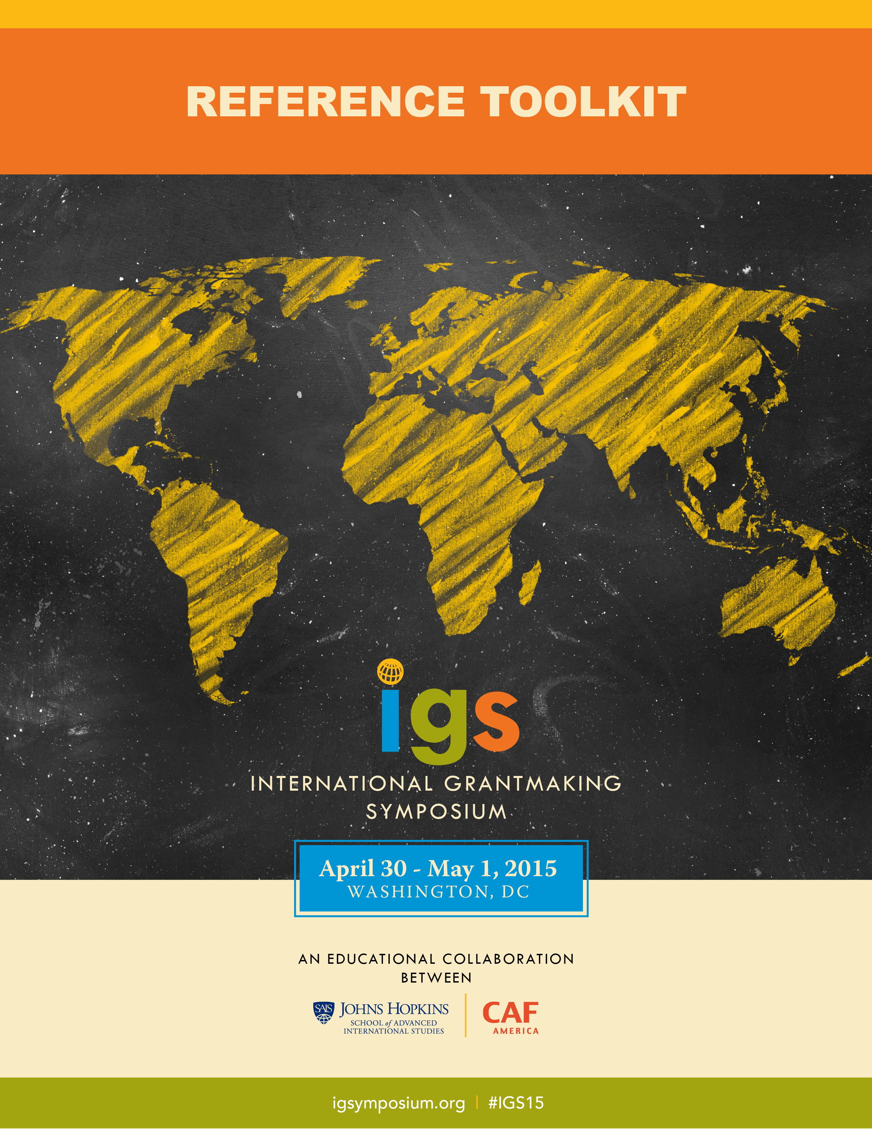

Welcome!
Thank you for your interest in the International Grantmaking Symposium (IGS) taking place in Washington, D.C. on April 30 – May 1, 2015.
We know that it’s not easy to identify the best opportunities that help us grow professionally. However, the real challenge is often getting the approval to participate in professional development events! We have developed the Reference Toolkit to assist you in showing your organization how your attendance in the IGS will benefit you, while also helping to increase your organization’s impact, and enabling meaningful connections within your field.
It is our goal to provide you with the resources that will help you best present the benefits of attending the IGS to your supervisor(s) and warrant their support of your participation.
In this Reference Toolkit, you will find:
- General tips  - Expense worksheet  - Letter of Support | - “Why attend?” – Quick Reference Sheet  - FAQs
Join us and reap the benefits of being in the company of speakers and participants representing prominent domestic and international institutions that come together in an event of high educational standard supported by the Johns Hopkins University’s Paul H. Nitze School of Advanced International Studies (SAIS), while gaining significant insights on compliance and best practices derived from 20+ years of experience of America’s leading global grantmaking organization.
See you in D.C.!
Ted Hart  CEO | Charities Aid Foundation of America  President | CAF Canada | Lindsey Waldrop  Director | Executive Education and Strategic Initiatives, Paul H. Nitze School of Advanced International Studies

GENERAL TIPS
Here are a few points to consider in developing your arguments supporting your participation and justifying the symposium related expenses:
- Identify the specific skills and knowledge you are expecting to gain
- Determine how these skills and knowledge will benefit your organization
- Highlight the networking opportunities by providing information about the speakers and the organizations they represent, while also pointing out other leaders in the field that will be involved as participants
- Offer to share the conference handouts with your colleagues; as a participant you will receive various handouts and templates that can be a useful resource supporting your work
- Prepare a strategy on how you are planning to use the IGS to build meaningful connections that could help increase your organization’s impact and visibility
- Be proactive in reorganizing your tasks and schedule so that your absence from the office will have a minimal impact on your organization; seek a colleague’s help in stepping in while you are away
- Suggest delivering a short presentation upon your return to share what you have learned with your colleagues
- See the Registration Fee section to find out whether you could benefit from a discounted participation fee! Also, check the FAQs for information on partnering hotels

EXPENSE WORKSHEET
Use this Expense Worksheet to help you prepare an overall estimate for attending the IGS:
EXPENSE | COST | NOTES
Registration Fee | $ | Early Bird Rate 25% discount!  Deadline: March 31, 2015
Thursday Evening Reception | $ 0 | Must sign up in advance
Symposium Materials | $ 0 | Provided at no additional charge
Hotel | $ | Check out the FAQs to find more information on the IGS partner hotel which is providing a reduced lodging rate for attendees
Flight | $ | Reagan National Airport (DCA)(metro accessible) or Dulles International Airport (IAD)
Transportation | $ | Be sure to include travel to and from the airport if flying, and parking fees if renting a car
Mileage | $ | If renting a car, see IRS guidelines to discover the 2015 mileage rate
Food Per Diem | $ | Remember that the IGS registration fee covers lunch on 04/30 and 05/01, networking breaks with refreshments and light snack, as well as an evening reception on 04/30.
Estimated TOTAL | $

SUPPORT LETTER
This ‘support letter’ is meant to serve as a template that can help you prepare the arguments you will present to your supervisor to show the benefits you and your organization will get as a result of your participation in the IGS.
This general template is a good place to start and it is highly recommended that you customize it to be relevant to your organization’s specific needs.
Dear <INSERT NAME>,
I would like to bring to your attention an educational event that I believe would greatly benefit my professional development and our organization alike, and thus I would like to sign up for it as an attendee. The International Grantmaking Symposium (IGS) organized by Charities Aid Foundation of America (CAF America) and the Johns Hopkins University’s Paul H. Nitze School of Advanced International Studies (SAIS) will take place on April 30 - May 1, 2015 in Washington, D.C.
The IGS (www.igsymposium.org) is focusing on topics that are directly relevant to my work, and its three angled-approach aiming to provide inspiration and education, while highlighting application reinforces my trust that I will gain valuable knowledge and experience from participating in the event.
A number of specific presentations address issues specifically related to <INSERT YOUR PRIMARY ROLE HERE> and provide valuable information on how to <INSERT BENEFITS TO YOU AND YOUR ORGANIZATION>. See Schedule at-a-Glance. See Detailed Curriculum.
A 25% discount if offered for Early Bird registration (by March 31, 2015)! This fee includes admission to all sessions, handouts and symposium materials, refreshments and coffee, lunch on the premises and entrance to the Thursday evening reception. See below the breakdown of participation cost:
Airfare: <$AMOUNT>
Hotel: <$AMOUNT>
Transportation: <$AMOUNT>
Meals: <$AMOUNT>
Discounted Registration Fee: <$AMOUNT>

The total cost of attending the IGS: <$TOTAL>

The opportunity to learn and make meaningful connections, while also benefiting from working within a select group of leaders and peers with remarkable expertise in <INSERT RELEVANT FIELD/TOPIC> warrants my attendance at the IGS as a smart use of resources that will yield rich dividends for <INSERT NAME OF ORGANIZATION>.
Thank you for your consideration,
<INSERT NAME>
“WHY ATTEND?”
QUICK REFERENCE SHEET

A series of thought-provoking presentations, inspiring panel discussions, and hands-on application sessions will provide participants with an in-depth understanding of international grantmaking, while also considering its critical role in shaping society. The IGS will present best practices in international grantmaking, while addressing the challenges and showing how to seize opportunities; it will clarify IRS rules and regulations and specifics of equivalency determination and expenditure responsibility; it will discuss the role of anti-money laundering (AML) in international grantmaking, impact measurement, and much more.
The IGS will offer the opportunity to learn from each other and make meaningful connections, as the advantages of a practical approach will be enhanced by the benefits of working within a select group of peers with remarkable expertise in their respective fields. Other featured speakers of the IGS include:
- Dr. Tomicah Tillemann | Keynote Speaker | Senior Fellow • Director, Bretton Woods II • New America
Formerly Senior Advisor to the Secretary for Civil Society and Emerging Democracies, U.S. Department of State
- Jacob Clauson | Director, Compliance FIDELITY Charitable
Co-author, Beyond Our Borders: A Guide to Making Grants Outside the United States.
- Heather Grady | Senior Fellow, Rockefeller Philanthropic Advisors
- Paula Fabiani | President, Institute for the Development of Social Investment (IDIS)
- Paul Ladd | Head of Post 2015 Development Agenda, UNDP

To round up the symposium, attendees have the option for a site visit to the U.S. Department of State Office of Global Partnerships.
See also FAQs | About the IGS: “Who should attend?”  “What does an attendee get upon the completion of the IGS?”

INTERNATIONAL GRANTMAKING SYMPOSIUM

FAQs

- ABOUT THE IGS
- PRACTICAL INFORMATION
- WHERE DO I FIND…?
- PARTICIPATION FEE AND DISCOUNTS
- WHO SHOULD I CONTACT?

- ABOUT THE IGS

- What is the goal of the symposium? What should registrants expect to gain from IGS?

The IGS is an educational symposium comprised of a series of presentations and interactive workshops where participants have the opportunity to get acquainted with the rules and norms regulating international grantmaking while also gaining significant insights on compliance and best practices derived from 20+ years of experience of a leading global grantmaking organization in the United States. Aiming to provide a truly hands-on experience and a crash-course in international grantmaking, the IGS offers INSPIRATION, EDUCATION and APPLICATION!

- What are the topics covered?

Sessions will include: International Grantmaking Best Practices | Overcoming challenges and seizing opportunities • IRS Rules & Regulations • Practitioners Discuss IRS Protocols: ER & ED • The Role of Anti-Money Laundering (AML) in International Grantmaking • Due Diligence and Risk Mitigation • Impact Measurement and much more!

Visit the IGS website to view the Schedule-at-a-Glance and the Detailed Curriculum.

- What will the application sessions entail?

The application sessions explore the practical questions, challenges, and solutions professionals deal with in relation to international grantmaking. For example, the workshop offered on Thursday afternoon will focus on hands-on activities that bring the expenditure responsibility and equivalency determination sessions to life. Working in small groups, we will explore various case studies to determine best routes for making an international grant in the given scenarios, as well as the tools should be used to do so. Among others, we will answer the unusual question: Is an elephant a capital asset?

- What is the audience you are expecting at this event?

The Symposium is recommended to nonprofit organizations, corporate foundations and corporations interested in engaging in international grantmaking and/or international giving. The participants will include grants managers, grants officers, other professional members of grants departments, CSR managers, corporate foundation managers and many others.

- Who should attend?

The Symposium is recommended to nonprofit organizations, corporate foundations and corporations interested in engaging in international grantmaking and/or international giving. There are a variety of reasons why you may be interested in attending this symposium:
- If you are launching an international grants department or managing an existing one
- If you are a grants team member or a team lead of an organization that currently makes or would like to begin providing international grants
- If you are the primary point person for your company’s international giving strategy
- If you want to ensure that your organization’s efforts in international grantmaking are a driving force leading to greater social justice and the growth of civil society

This symposium will provide you the tools to gain an in-depth understanding of international grantmaking, identify new opportunities and successfully navigate the challenges of international philanthropy.
- How many people do you expect will attend?

Aiming to deliver a truly hands-on educational experience, the IGS will be limited to a maximum of 30 participants.

- Where can I find bios of each of the speakers?

To learn more about the speakers of the IGS visit www.igsymposium.org.

- What does an attendee get upon completion of the IGS?

Participants will be awarded a certificate of completion upon conclusion of the International Grantmaking Symposium organized by Charities Aid Foundation of America (CAF America) in conjunction with Johns Hopkins School of Advanced International Studies (SAIS).

- PRACTICAL INFORMATION

- Where will the symposium take place?

The Symposium will take place at the Johns Hopkins University, Paul H. Nitze School of Advanced International Studies (SAIS) in Washington, D.C. Visit the IGS website for updates on the exact location of the sessions or sign up to our mailing list to receive updates on the Symposium.

- Are any meals or beverages included?

The registration fee includes admission to all sessions, handouts and symposium materials, refreshments provided during breaks, lunch on premises and entrance to the Thursday evening reception.

- Are there any hotels nearby? Are there hotel discounts for IGS attendees?

As an IGS partner, the Kimpton Topaz Hotel will offer attendees of the IGS a discounted rate of $249/night, April 29 – May 1, 2015.

Kimpton Topaz  www.topazhotel.com  Address  1733 N Street, NW  Washington DC 20002 | 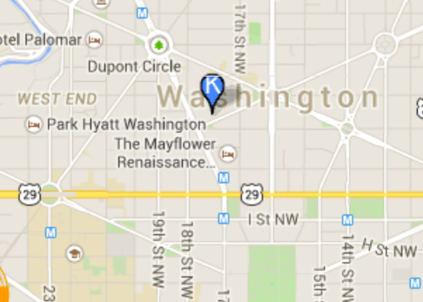

To receive the IGS discounted rate, please use the Rate Code: CRP when you make your reservation on www.kimptonhotels.com or when calling 1-800-Kimpton.

- Will there be parking at the symposium? What is the nearest metro access?

The closest metro access is Dupont Circle (red line). Parking is not provided on campus, however there is a public garage very close to the premises on 1800 Massachusetts Ave NW, Washington, DC 20036.

- Will the attendees earn continuing education credits by participating in the IGS?

No, unfortunately continuing education credits are not available.

- WHERE DO I FIND…?

- Where can I view and/or download the Schedule-at-a-Glance?

To view and/or download the Schedule-at-a-Glance click here or visit the IGS website at http://www.cafamerica.org/igs.

- Where can I view and /or download the Detailed Curriculum?

To view and/or download the Detailed Curriculum click here or visit the IGS website at http://www.cafamerica.org/igs.

- PARTICIPATION FEE AND DISCOUNTS

- What is the registration fee for the symposium and what does it include?

The $1,600 registration fee per participant includes admission to all sessions, handouts and symposium materials, refreshments and coffee, lunch on premises and entrance to the Thursday evening reception. Prior online registration is required.

- Is there an Early Bird discount available and what are its terms?

Yes, there is an Early Bird discount of 25% on the registration fee!

Register before March 31, 2015 to benefit from the Early Bird discount. Contact John Holm at igs@cafamerica.org to request the promo code. Use this code when registering via this link or through the IGS website and save with the Early Bird Rate!

- Are there any other discounts provided?

Is more than 1 participant registering from your organization? Contact John Holm at igs@cafamerica.org to request the promo code. Use this code when registering via the link above and save 25% with the Group Rate!

CAF affiliates and GMN members please reach out to John Holm at igs@cafamerica.org to inquire about further discounts.

- If I cancel my registration will I receive a refund?

Cancelations made on or before March 31, 2015 will receive a refund less a $100 administration fee.

No refunds will be given after March 31, 2015!

- WHO SHOULD I CONTACT?

- Who should I contact if I need assistance during registration and payment?

If you have any questions about registration, please contact Bahar Alagheband at execed@jhu.edu.

- Who should I contact with further questions and comments?

To learn more contact John Holm at igs@cafamerica.org or Bahar Alagheband at execed@jhu.edu or sign up through the IGS website to receive updates on the Symposium.

